**Day 50**

**What to do?**

Learn about VGGNet and different variations of it.

**VGG:**

VGG network is one the classic networks in deep convolutional models. The classic networks give us an intuition of how to build convnets on our own dataset. VGG network is also called as VGG-16, which was implemented and written in 2014. The number “16” represents the number of layers in the network. The network is super appealing as it has uniform architecture.

It consists

* convolutions of size 3x3, with stride 1 and SAME padding
* max pool layers of 2x2 size, with stride 2

Each layer consists of filters ranging from 64 to 512. The figure attached shows the VGG network.

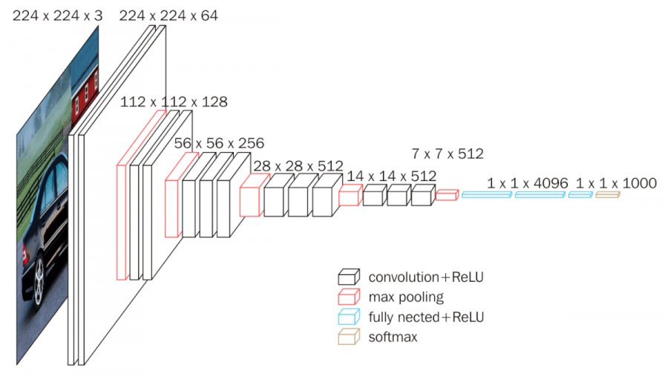

The network was trained on 4 GPUs for 2 to 3 weeks. Hence, the configuration of the network is available publicly. It is a widely used network for extracting features from images. VGG with 16 filters consists of almost 138 million parameters in total.

Another variation of VGG network is VGG-19, which consists of 19 filters.